Peter Victoratos

CSC 411

March 6th, 2018

Lab 10 Writeup

Img 1 With Keypoints

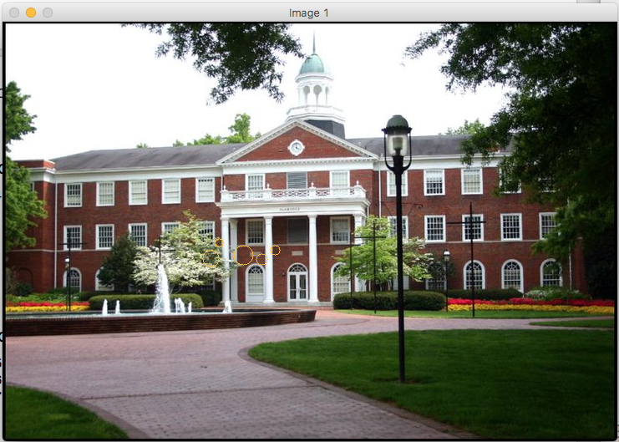

Img 2 With Keypoints

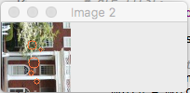

Keypoint Information Output

